EXPERIMENT-9

Name: Karthik V Rollno:240701234

To design input forms that validate data such as email and phone number and display error messages using HTML, CSS, and JavaScript.

Form validation is used to ensure that the user inputs correct and meaningful data before submitting a form. It improves data accuracy and enhances user experience by providing immediate feedback. In this experiment, a form is created and validated using HTML, CSS, and JavaScript.

SETTING UP HTML FORM:

<!DOCTYPE html>
<html lang="en">
<head>
<title>Form Validation</title>

<!-- Linking CSS file -->
<link rel="stylesheet" href="style.css">
</head>
<body>

<h2>Registration Form</h2>

<form id="myForm">
<label>Email:</label><br>
<input type="text" id="email"><br>
<span id="emailError"></span><br><br>

<label>Phone Number:</label><br>
<input type="text" id="phone"><br>
<span id="phoneError"></span><br><br>

<button type="submit">Submit</button>
</form>

</body>
</html>
<script src="https://cdnjs.cloudflare.com/ajax/libs/validator/13.9.0/validator.min.js"></script>
<script src="script.js"></script>

OUTPUT:
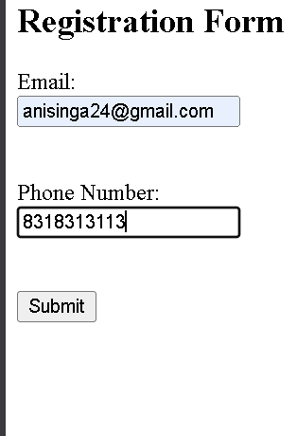

In this step, the basic structure of the form is created using HTML. Input fields are provided for email and phone number

STYLING USING CSS:

body {
font-family: Arial;
background-color: #f2f2f2;
text-align: center;
}

form {
background-color: white;
padding: 20px;
margin: auto;
width: 300px;
border-radius: 10px;
box-shadow: 0px 0px 10px gray;
}

input {
width: 90%;
padding: 8px;
margin-top: 5px;
}

button {
padding: 10px 20px;
background-color: blue;
color: white;
border: none;
}

span {
color: red;
font-size: 14px;
}

OUTPUT:
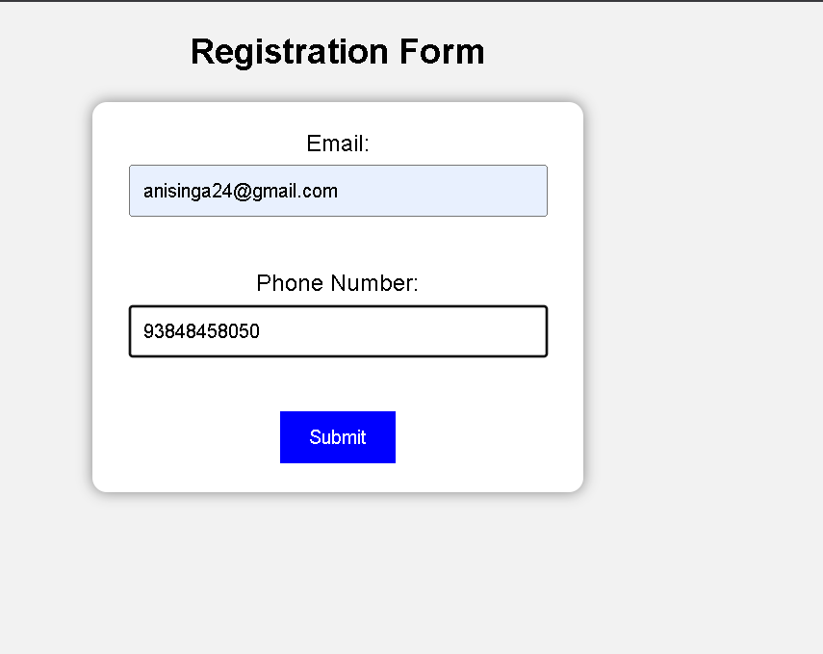
CSS is used to enhance the visual appearance of the form by adding styles such as background color, spacing, alignment, and button design.

VALIDATION USING JAVASCRIPT:

document.getElementById("myForm").addEventListener("submit", function(event) {

event.preventDefault(); // stop default submit

let email = document.getElementById("email").value;
let phone = document.getElementById("phone").value;

let emailError = document.getElementById("emailError");
let phoneError = document.getElementById("phoneError");

emailError.textContent = "";
phoneError.textContent = "";

let valid = true;

// Email validation
if (!validator.isEmail(email)) {
emailError.textContent = "Invalid email format";
valid = false;
}

// Phone validation
if (!validator.isMobilePhone(phone, 'any')) {
phoneError.textContent = "Invalid phone number";
valid = false;
}

// ✅ If valid → show success message
if (valid) {
alert("Form submitted successfully!");

// Optional: clear form
document.getElementById("myForm").reset();
}
});

OUTPUT:
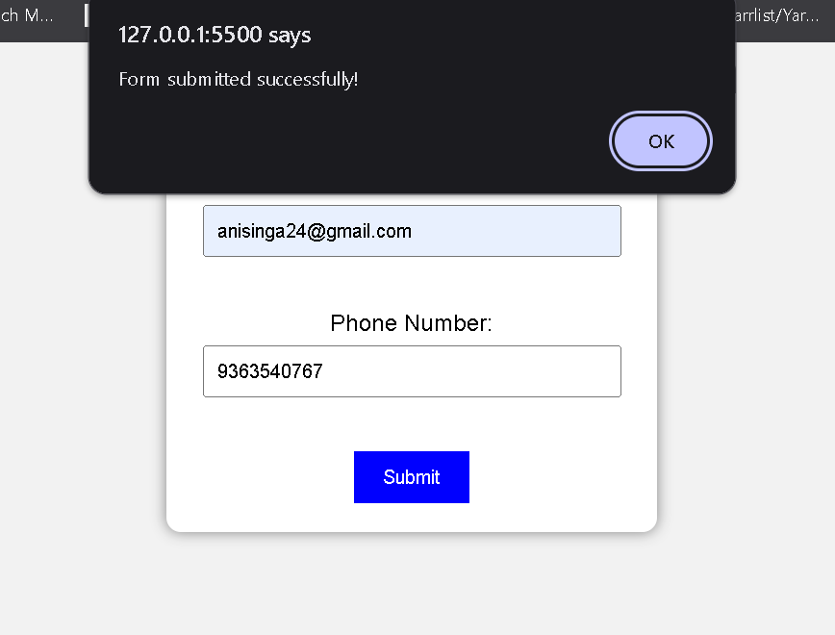
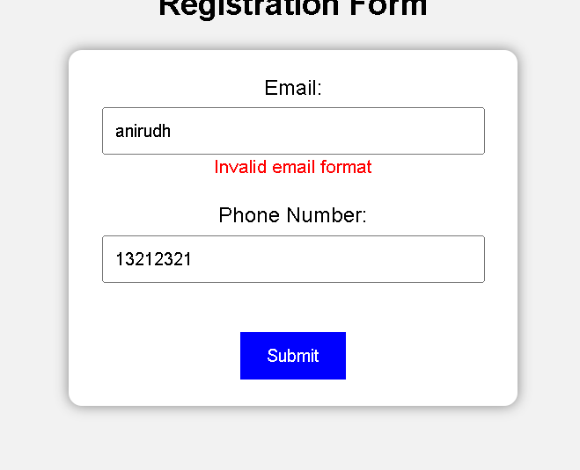

JavaScript is used to validate the input fields. It checks whether the email contains “@” and “.” and verifies that the phone number is exactly 10 digits. Error messages are displayed if validation fails.

